
Patient Information Leaflets
Order Form

Date of order*
Purchase Order Reference* |  | *Mandatory fields

Delivery details
Contact name* |  | Department
Phone number |  | E-mail*
Hospital / Foundation
Delivery address*  Post code: |  | Invoice address leave blank if same as delivery address  Post code:
Note: The minimum order is 100 leaflets. This can be an order of 100 of one leaflet or various different leaflets totaling 100
Your order (see below / overleaf for pricing breakdown)
Total volume of leaflets
Leaflet cost total | £
Delivery charge | £
Order total* | £
Please note that we do not add VAT to our orders

Leaflet | Quantity |  | Leaflet | Quantity
Acute Pancreatitis |  |  | Healthy Eating & the Digestive System
Barrett’s Oesophagus |  |  | Heartburn & Reflux
Bowel Cancer |  |  | Helicobacter pylori
Coeliac Disease |  |  | Indigestion
Chronic Pancreatitis |  |  | Irritable Bowel Syndrome (IBS)
Constipation |  |  | Pancreatic Exocrine Insufficiency (PEI)
Crohn's Disease |  |  | Polyps in the Bowel
Diarrhoea |  |  | The Role of Gut Bacteria in Health & Disease
Diverticular Disease |  |  | Ulcerative Colitis
Gut Microbiome (Poo Testing)
Please return your completed order form to: Leaflets@gutscharity.org.uk

Leaflet and delivery pricing
Leaflet Price | NHS | Private | Please see overleaf for more detailed price calculations. Please ensure the price you input above tallies with our pricing tables
Price per 100 Leaflets | £25 | £36
Price per leaflet | 0.25 | 0.36
Delivery Charge to UK mainland (may take up to 28 days) |  |  | Surcharges apply for orders to offshore / highland locations. Please see overleaf.  For deliveries to Ireland, please contact us directly
Up to 500 leaflets |  | £15
501 - 1,000 leaflets |  | £26
1,001 – 2,000 leaflets |  | £32
2,001 – 3,000 leaflets |  | £46

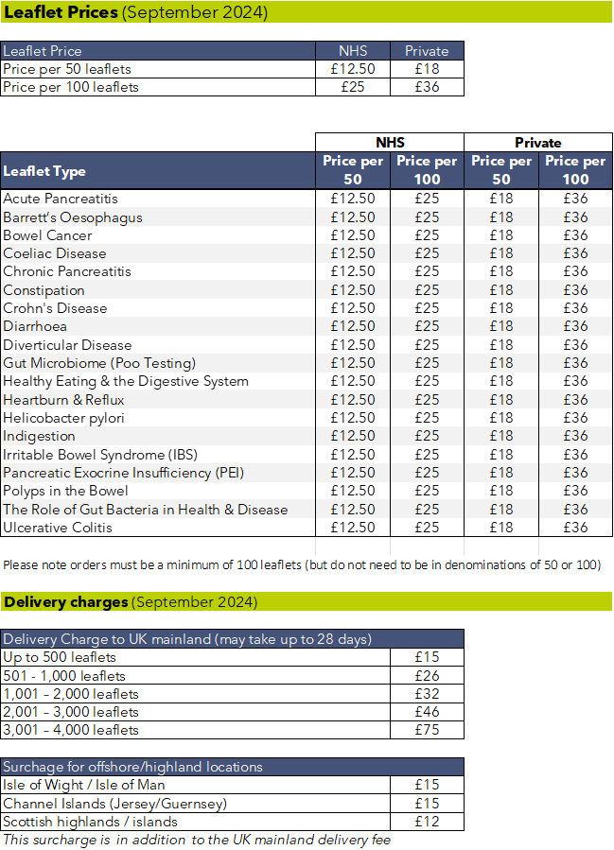

For orders to The Republic of Ireland or for orders over 4,000 leaflets, please call us directly on 0207 4860 341 or e-mail us at finance@gutscharity.org.uk

